**MOOKAMBIGAI COLLEGE OF ENGINEERING**



**Srinivasa Nagar, Kalamavur-622 502.**

**CS8711 – CLOUD COMPUTING LAB**

**2022-2023**

**VII Semester**

**DEPARTMENT OF**

**COMPUTER SCIENCE AND ENGINEERING**

# MOOKAMBIGAI COLLEGE OF ENGINEERING

**(Approved by AICTE & Affiliated to Anna University of Technology, Chennai) (NBA Accredited, ISO 9001:2008 Certified Institution)**

# Srinivasa Nagar, Kalamavur-622502, Pudukkottai District, Tamil Nadu.

**Name……………………………………………………………………………………….......**

# Year………………………. Semester………………………… Branch………………….....

**University Register No:**

|  |  |  |  |  |  |  |  |  |  |  |  |
| --- | --- | --- | --- | --- | --- | --- | --- | --- | --- | --- | --- |
|  |  |  |  |  |  |  |  |  |  |  |  |

# CERTIFICATE

**Certified that this is the Bonafide record of work done by the above student in the**

# CS8711-CLOUD COMPUTING Laboratory during the year 2022-2023.

**Signature of Staff In-charge Submitted for the University practical Examination held on…………………………..**

**EXAMINERS**

**Date: ………………. Internal: …………………….**

# External: ……………………

**INDEX**

| **EXPERIMENT** | | **NAME OF THE EXPERIMENT** | **PAGE NO.** | **SIGNATURE** |
| --- | --- | --- | --- | --- |
| **NO** | **DATE** |
| 1 |  | Install Virtualbox/VMware Workstation with different flavours of linux or windows OS on top of windows7 or 8. |  |  |
| 2 |  | Install a C compiler in the virtual machine created using virtual box and execute Simple Programs |  |  |
| 3 |  | Install Google App Engine. Create *hello world* app and other simple web applications using python/java. |  |  |
| 4 |  | Use GAE launcher to launch the web applications. |  |  |
| 5 |  | Simulate a cloud scenario using CloudSim and run a scheduling algorithm that is not present in CloudSim. |  |  |
| 6 |  | Find a procedure to transfer the files from one virtual machine to another virtual machine. |  |  |
| 7 |  | Find a procedure to launch virtual machine using trystack (Online Openstack Demo Version) |  |  |
| 8 |  | Install Hadoop single node cluster and run simple applications like wordcount. |  |  |

**Step 2:** Select the iso file of the virtual OS Windows7 and click Start.

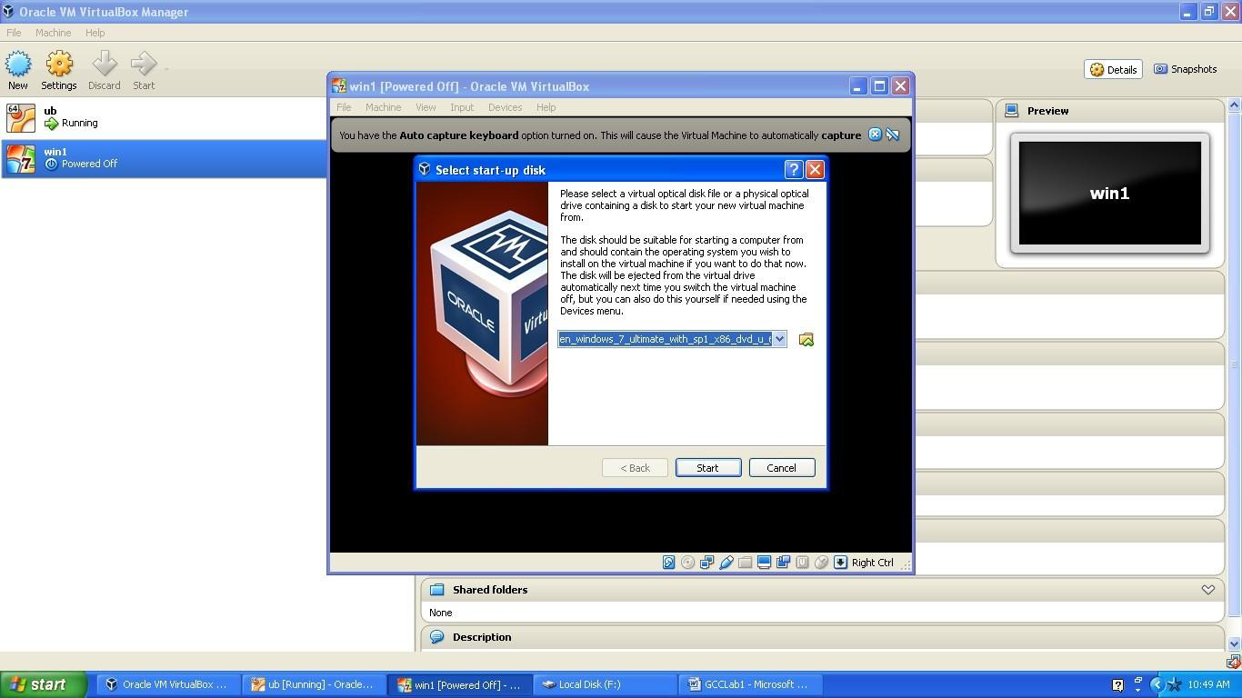

**Step 3:** Select the language to use in the Operating System and click Install Now.

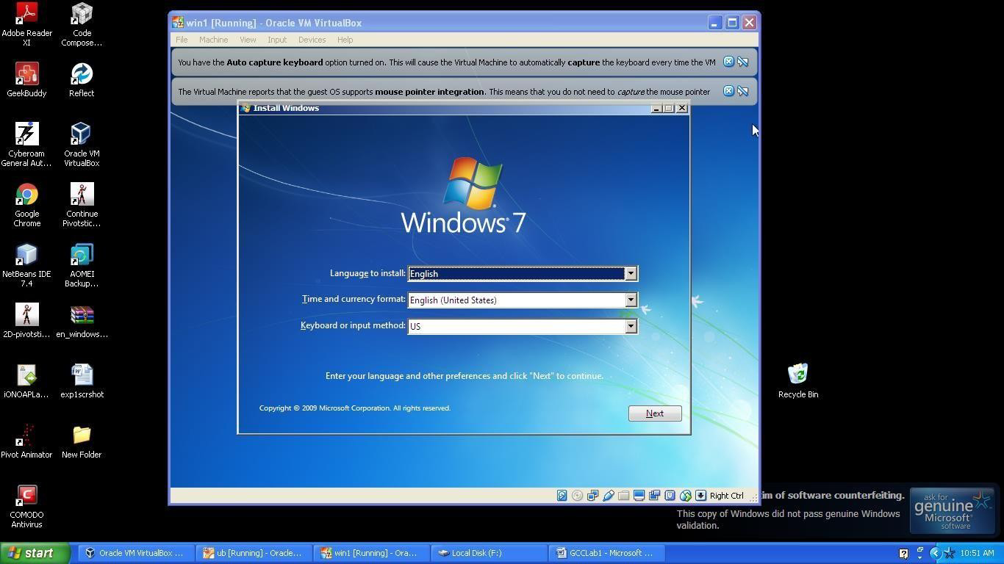

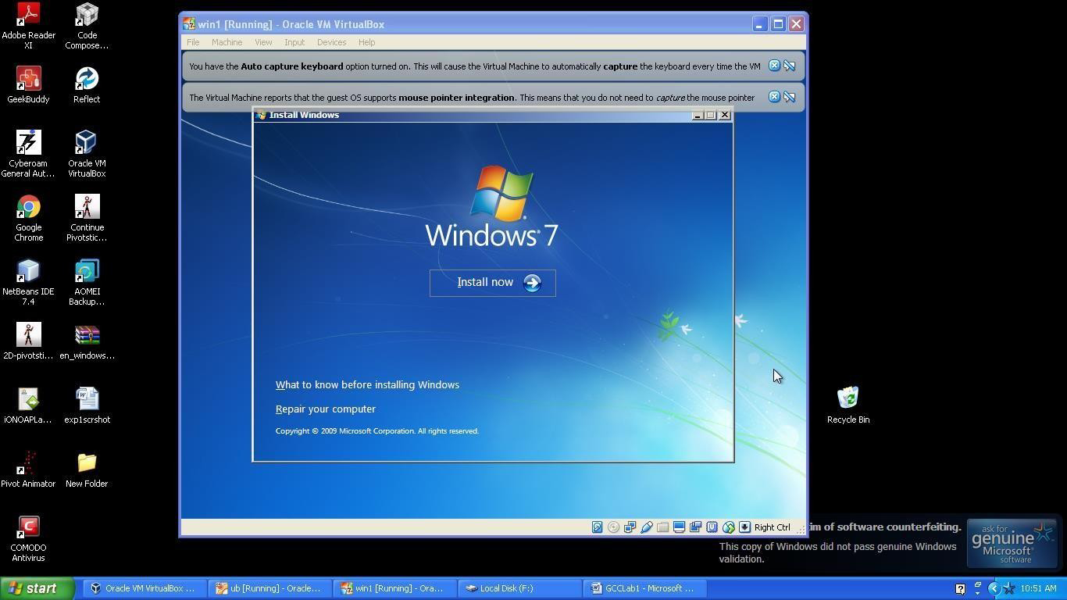

**Step 4:** Select the type of installation as Custom for new installation and allocate Disk space according to your convenience. Click Next to start the installation.

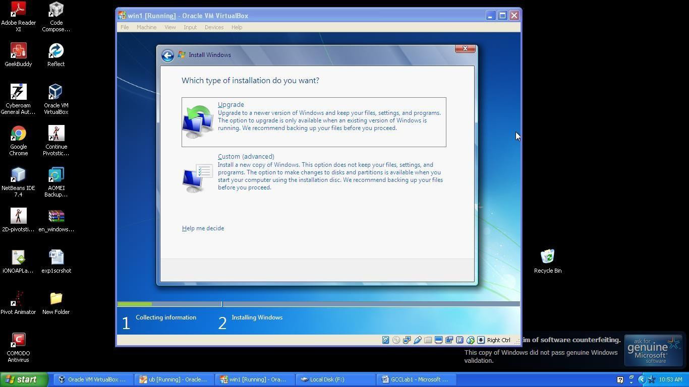

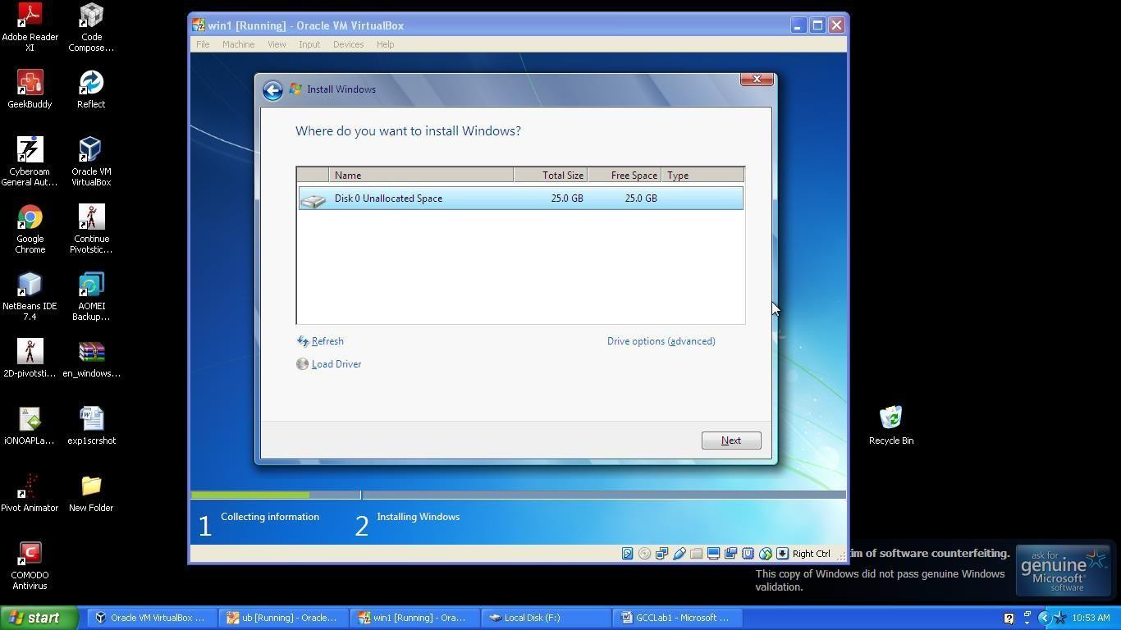

**Step 5:** After installation the system will be restarted to complete the installation.

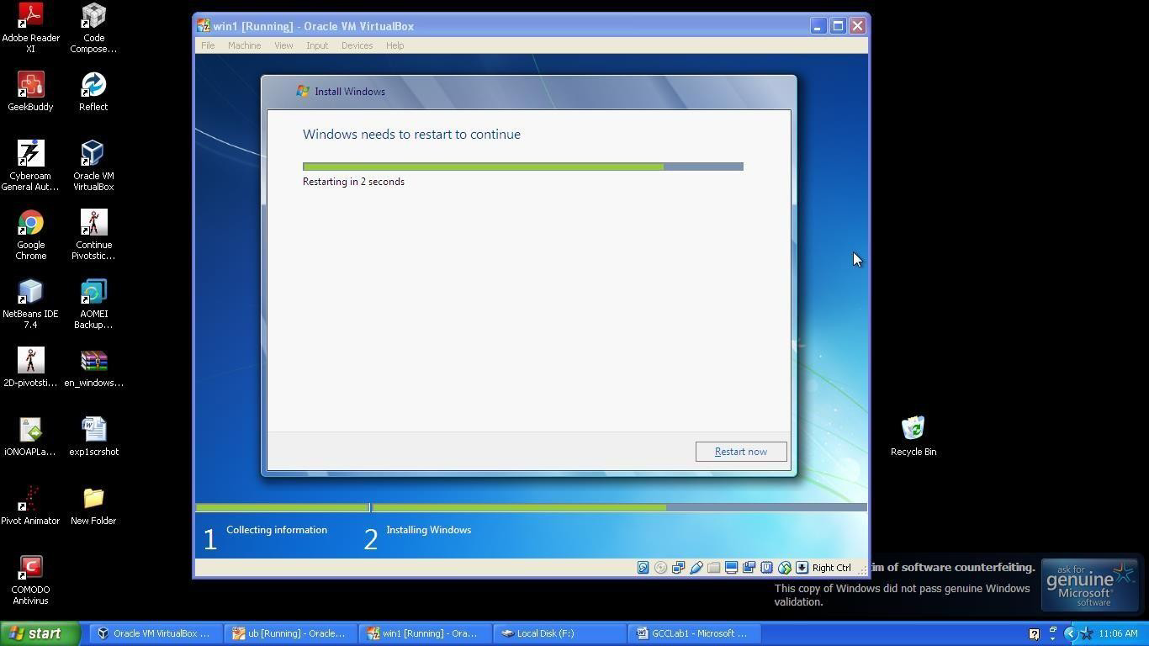

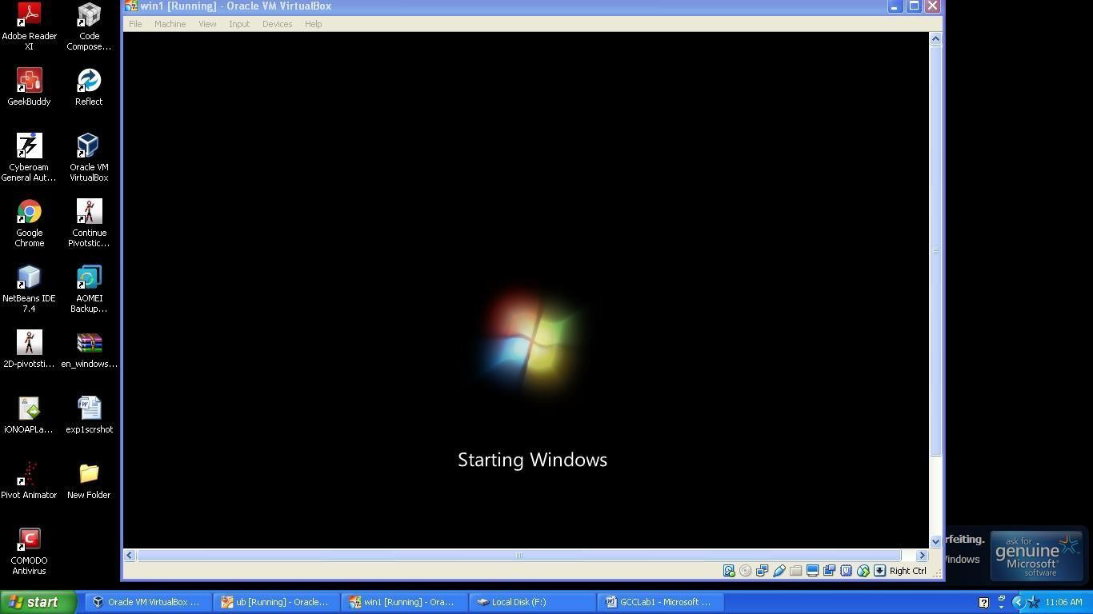

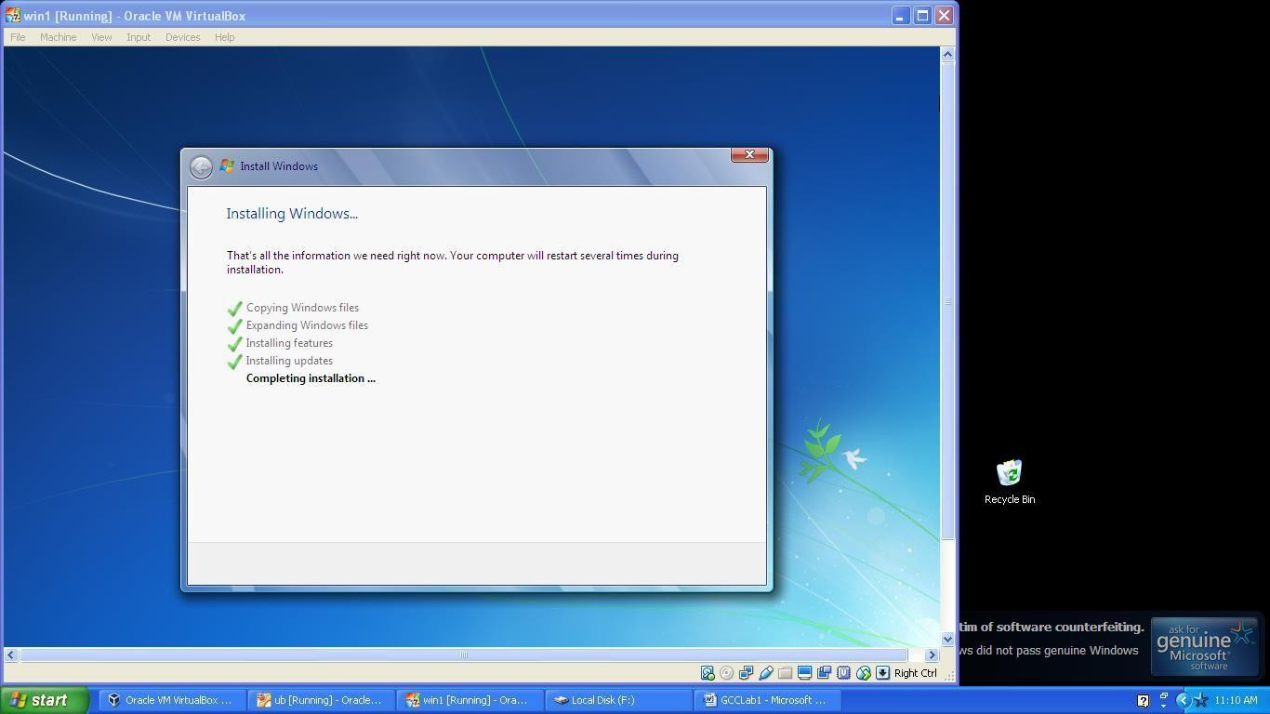

**Step 6:** Provide a user name and password(optional) to gain access over the OS.

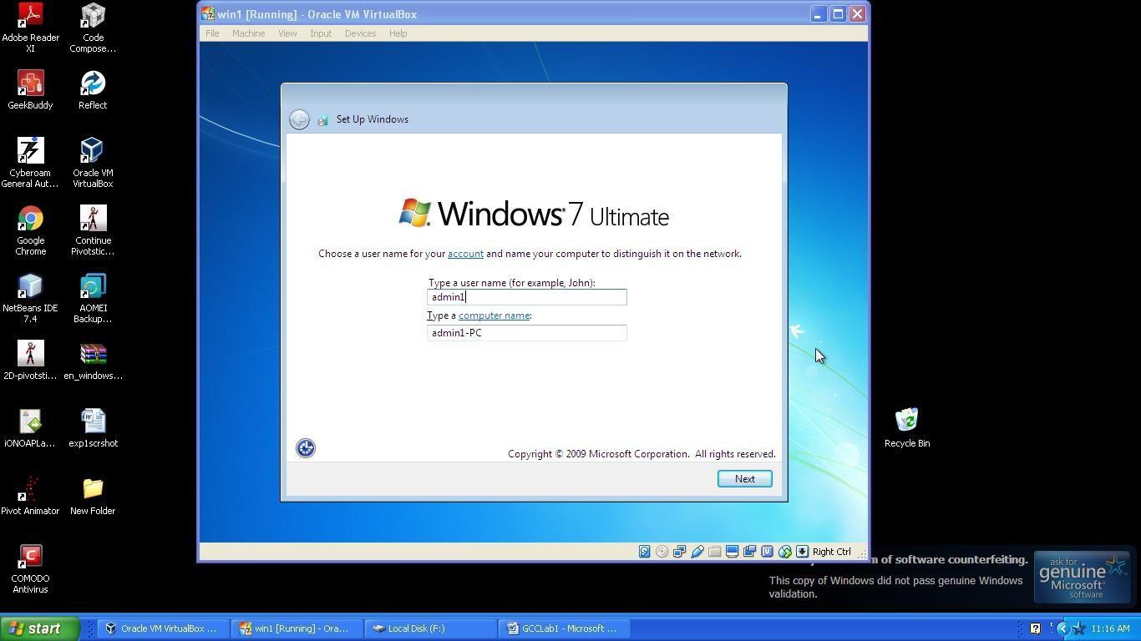

**Step 7:** Set the time and date for the new Operating System.

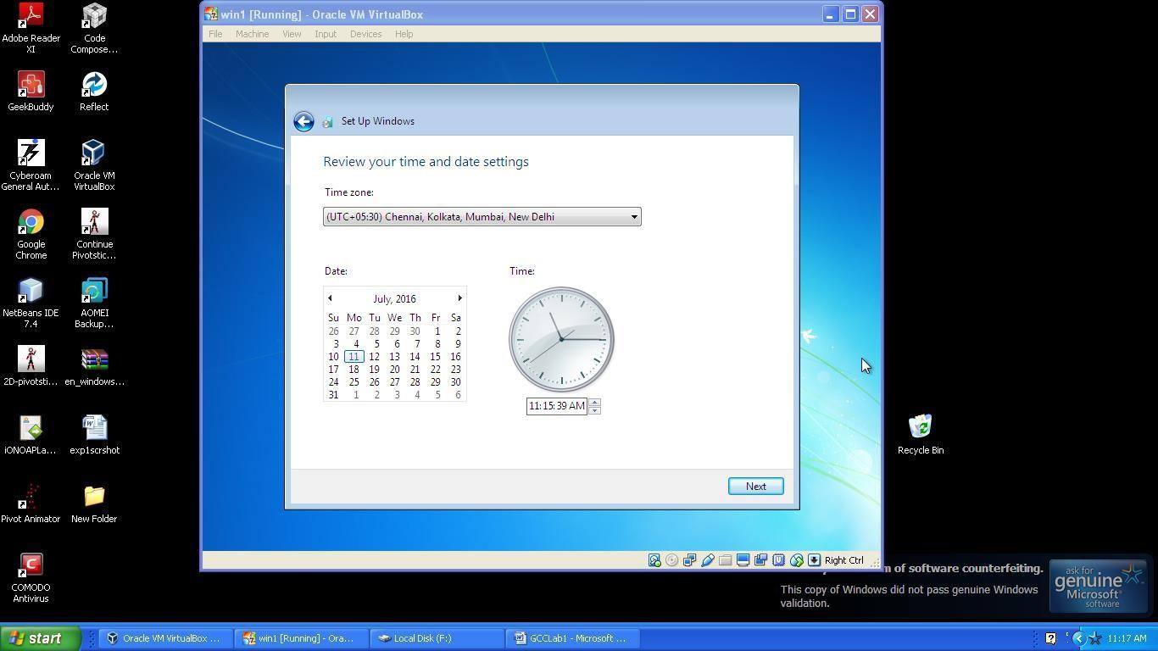

**Step 8:** Thus the new Operating System Windows7 will be opened as the virtual machine.

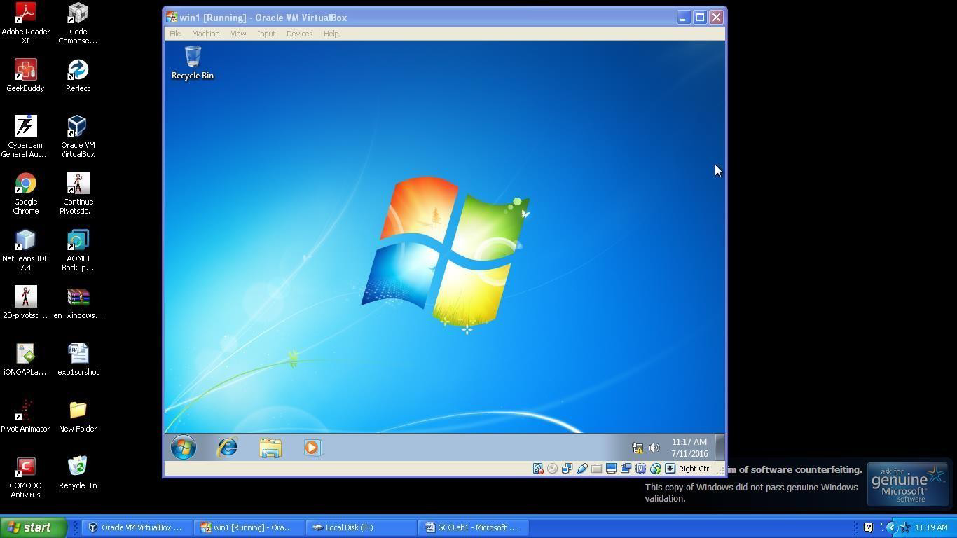

# RESULT:

Thus the above procedure to install Virtualbox/VMware Workstation with different flavours of linux or windows OS on top of windows7 or 8 is checked.

| **Ex. No:2**  **Date:** | **Install a C compiler in the virtual machine created using virtual box and execute Simple Programs** |
| --- | --- |

# AIM:

To find a procedure to install a C compiler in the virtual machine and execute a sample program.

# PROCEDURE:

**Installing Ubuntu using Oracle Virtual Box**

**Step1:** Open Oracle virtual box manager and click create new -> virtual machine.

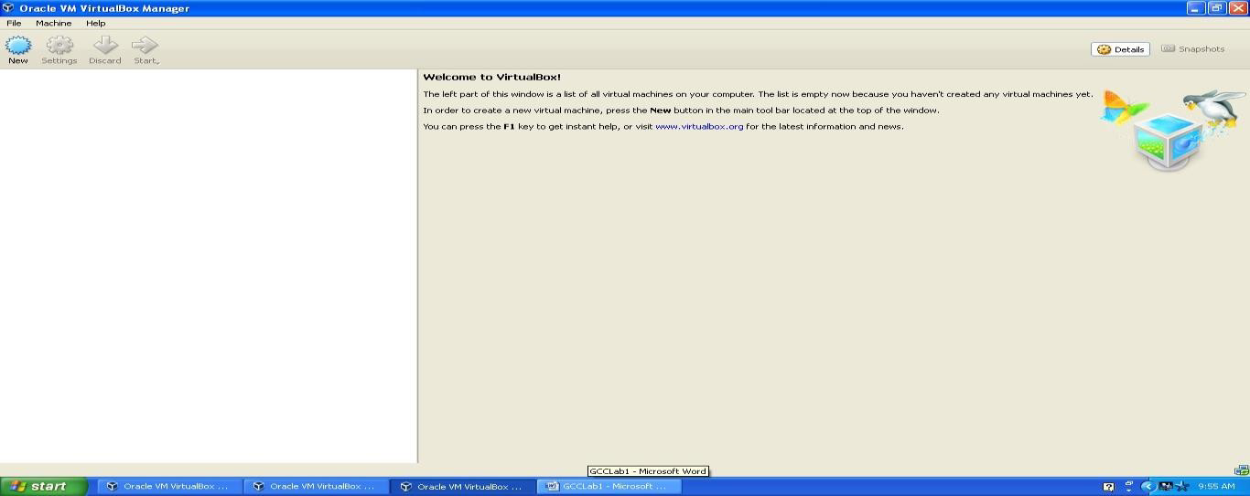

**Step 2**: Provide a name for the virtual machine and select the hard disk size for the virtual machine. Select the storage size as Dynamically allocated memory size and click OK. The virtual machine will be created.

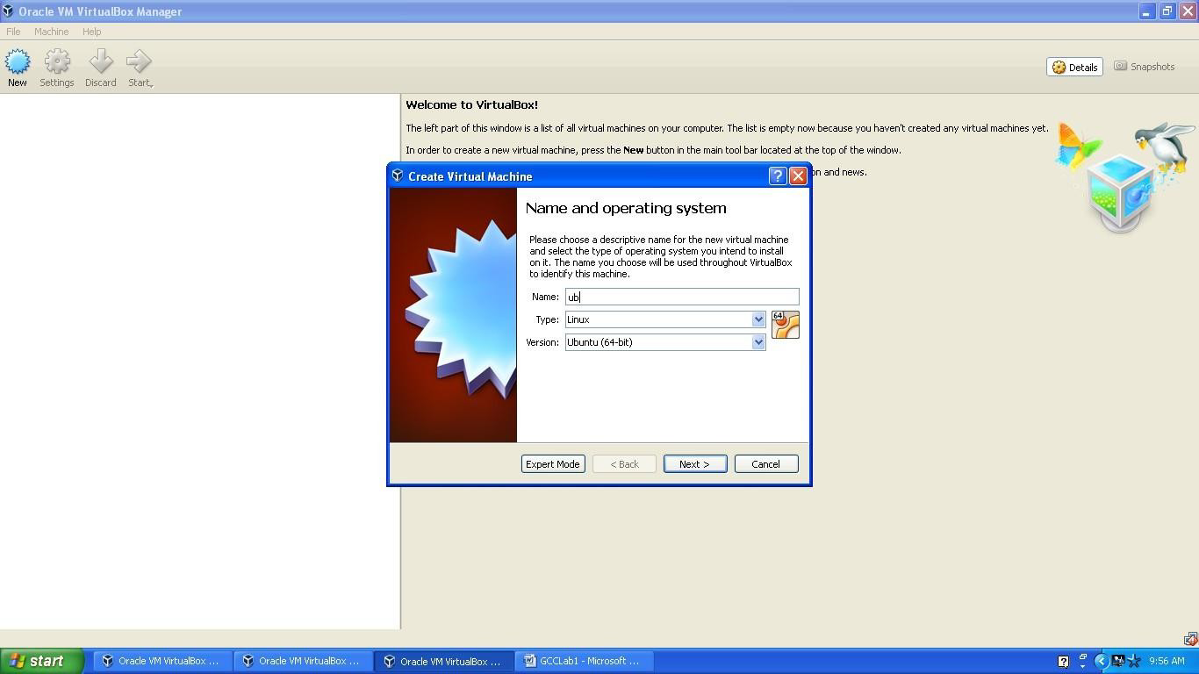

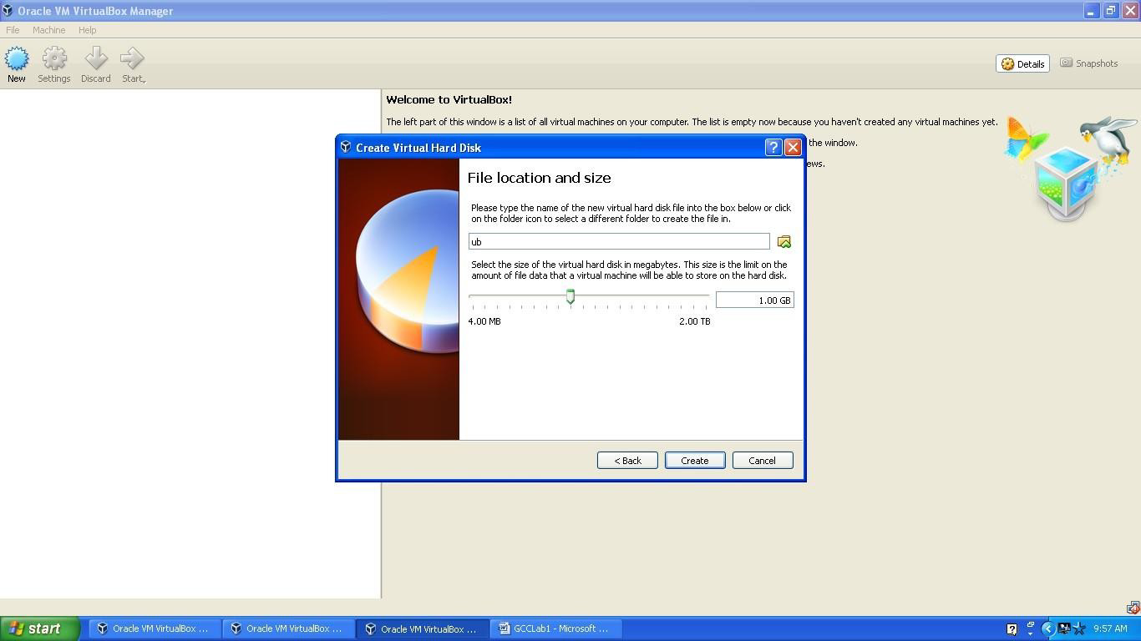

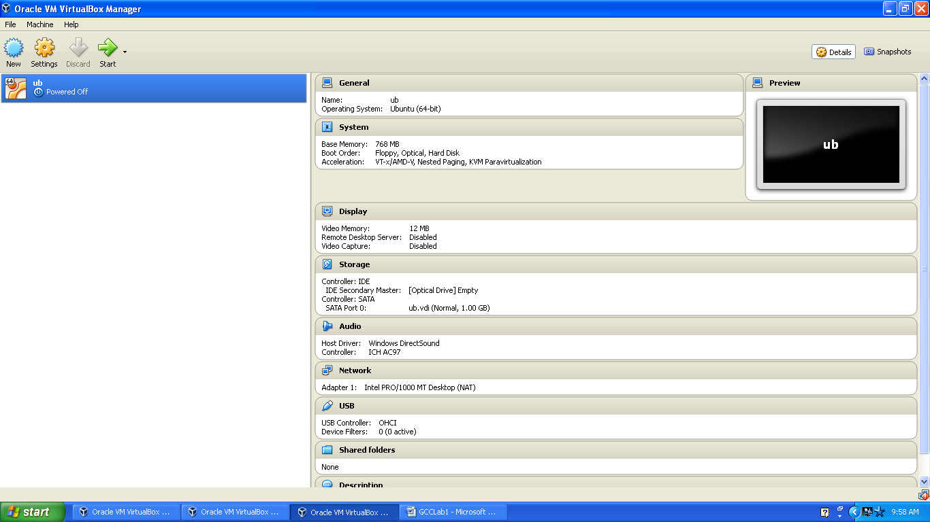

**Step 3:** Select the iso file of the virtual OS Ubuntu and click Start.

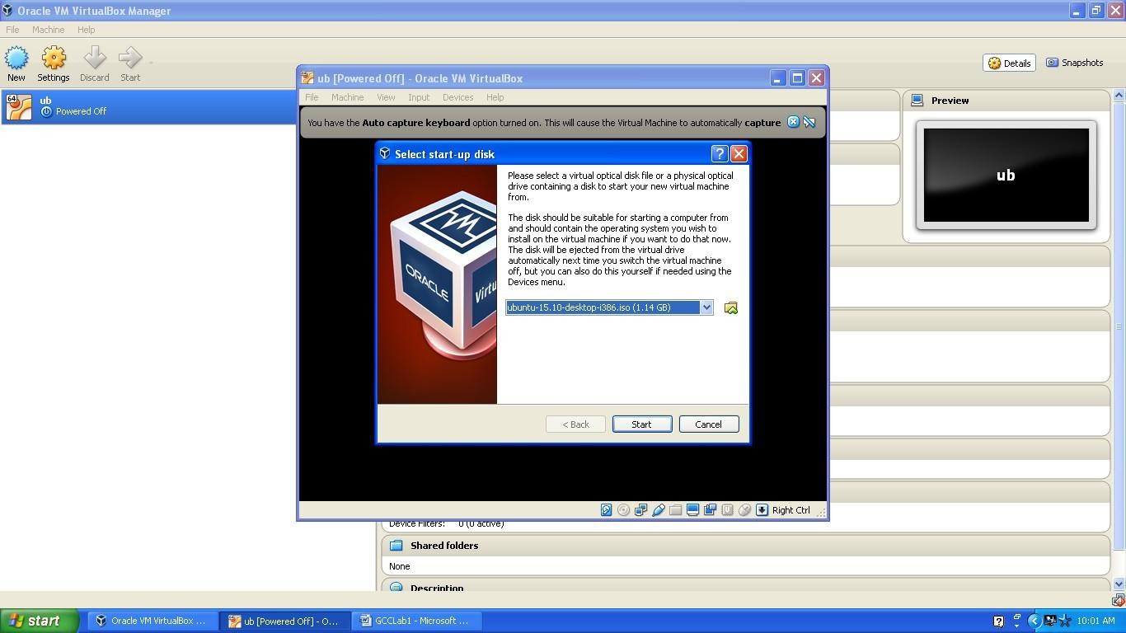

**Step 4:** The virtual OS Ubuntu is opened successfully. Now type “gedit” in the search box to open text editor in Ubuntu.

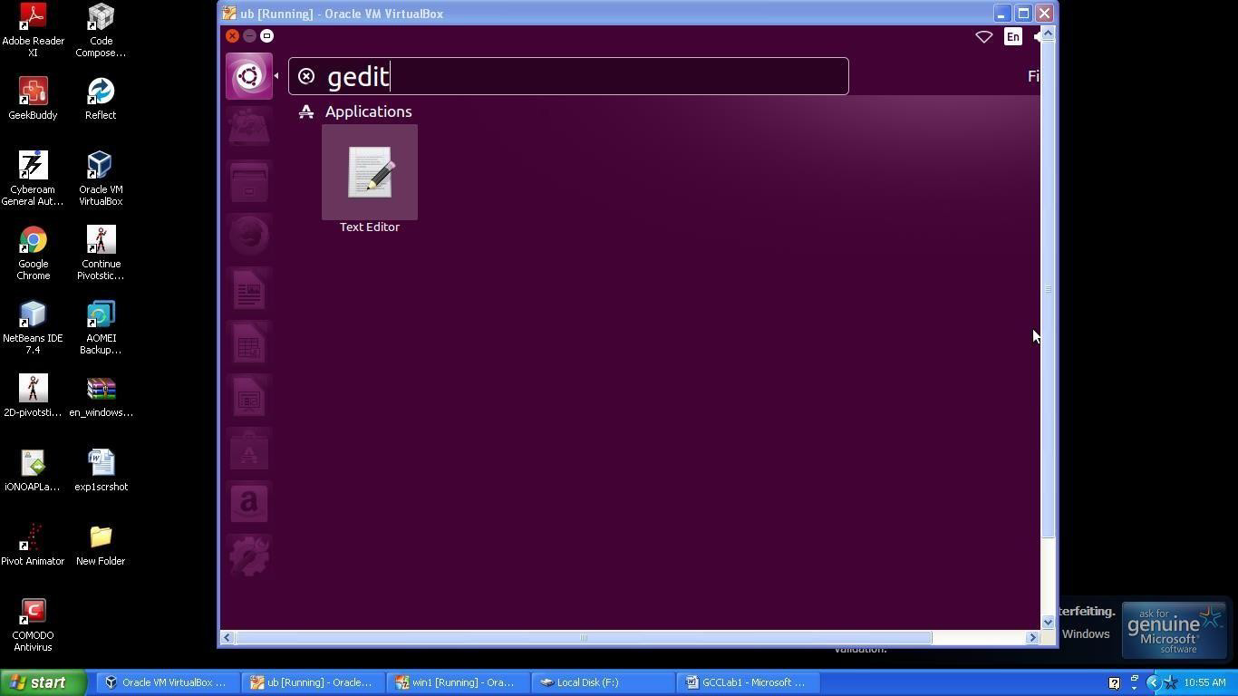

**Step 5**: Type your desired C program in text editor and save it with the extension (.c)

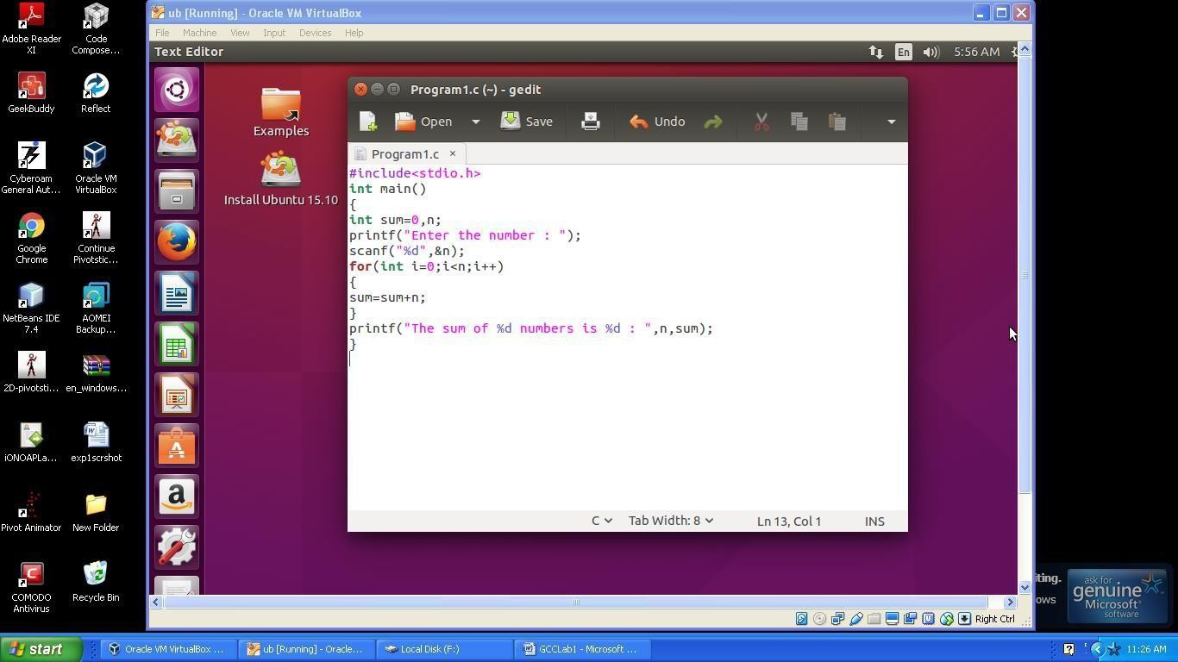

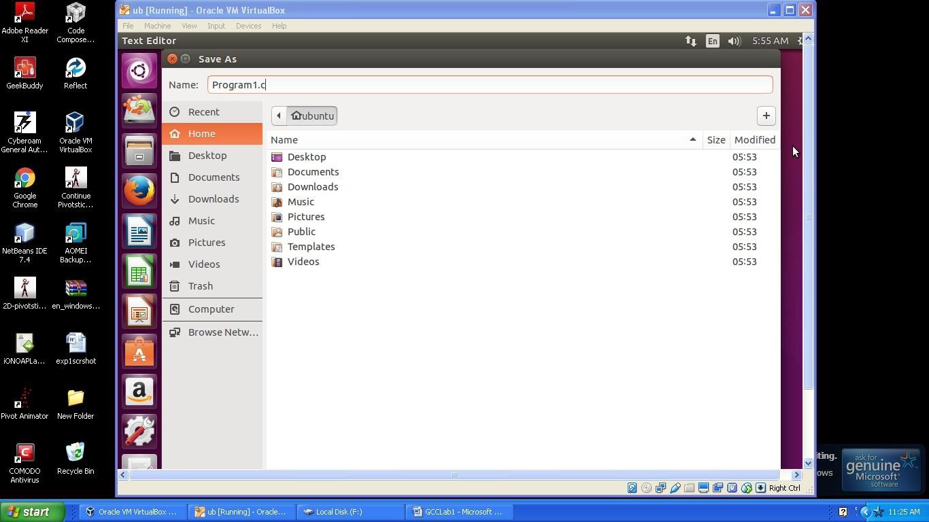

**Step 6:** Type “terminal” in the search box to open the command window.

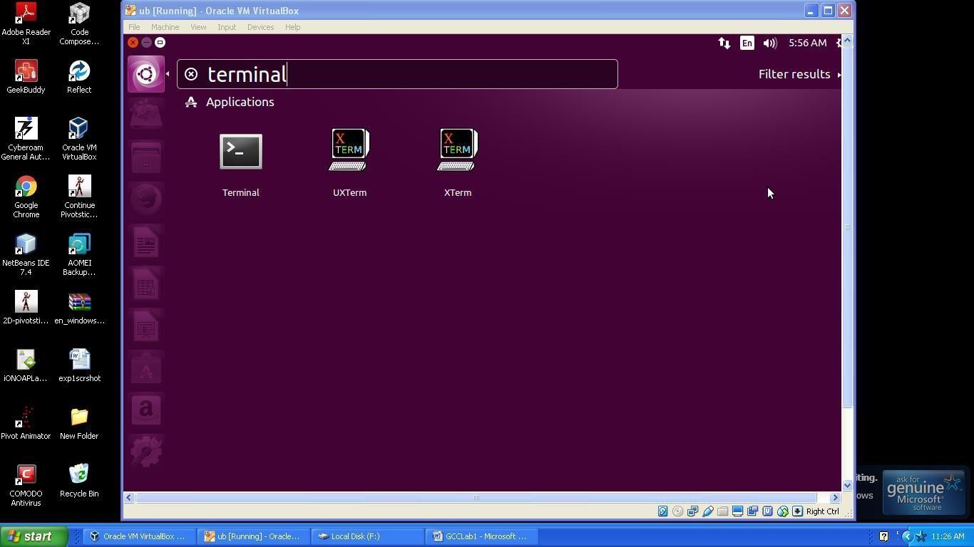

**Step 7:** Type the necessary commands to compile and run the C program.

1. cc_filename to compile the C program.
2. ./a.out to display the output of the last compiled program.

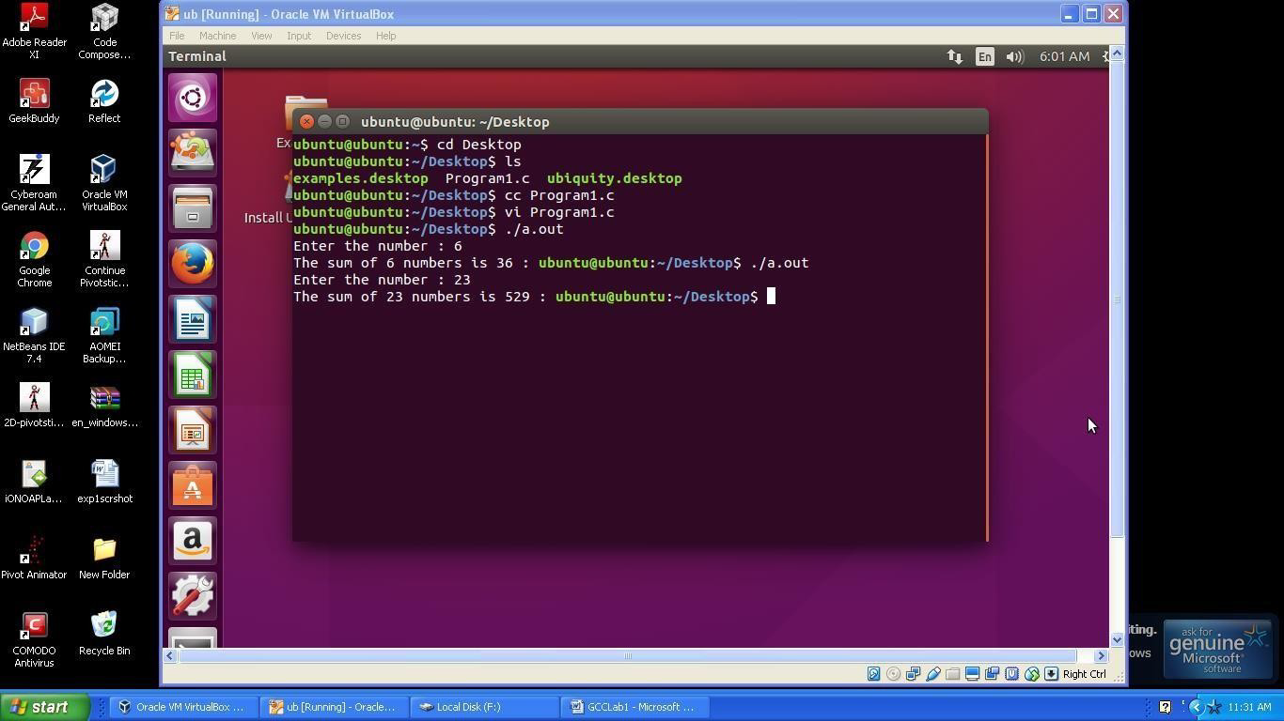

# RESULT:

Thus a C compiler is successfully installed in the virtual machine created using virtual box and a simple c program is compiled and output is verified successfully.

| **Ex. No:3**  **Date:** | **Install Google App Engine. Create *hello world* app and other simple web applications using python/java.** |
| --- | --- |

# AIM:

To install Google App Engine and Create *hello world* app and other simple web applications using python/java.

# PROCEDURE:

This document describes the installation of the Google App Engine Software Development Kit (SDK) on a Microsoft Windows and runninga simple“hello world” application.

The App Engine SDK allows you to run Google App Engine Applications on your local computer. It simulates the run-­‐time environment of the Google App Engine infrastructure.

## Pre-•Requisites: Python 2.5.4

Ifyou don'talreadyhave Python 2.5.4 installedinyourcomputer, download and Install Python 2.5.4 from:

<http://www.python.org/download/releases/2.5.4/>

## Download and Install

You can download the Google App Engine SDK by going to: <http://code.google.com/appengine/downloads.html>

and download the appropriate install package.

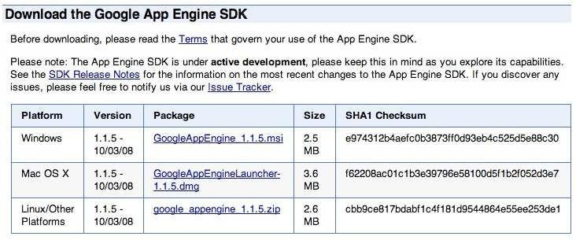

Download the Windows installer – the simplest thing is to download it to your Desktop or another folder that you remember.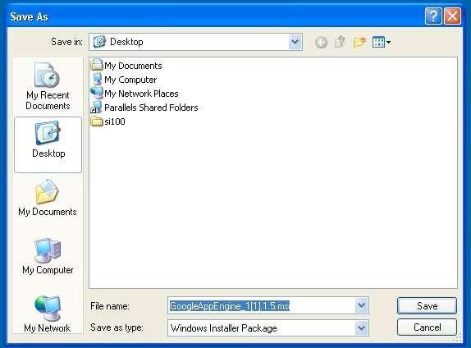

Double Click on the **GoogleApplicationEngine** installer.

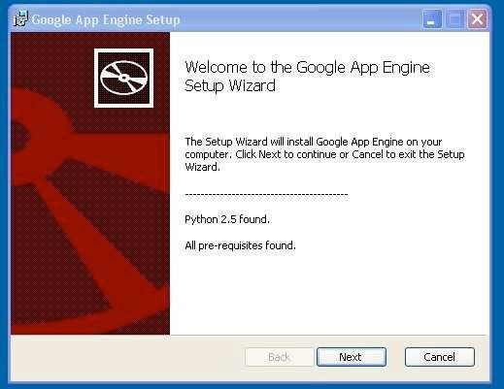

Clickthroughtheinstallationwizard, anditshouldinstalltheApp Engine. If youdo not have Python 2.5, it will install Python 2.5 as well.

Once the install is complete you can discard the downloaded installer

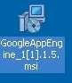

## MakingyourFirstApplication

Nowyouneedtocreateasimpleapplication. Wecouldusethe“+”optiontohave thelaunchermake us an application– but instead we will doitbyhandtogeta better sense of what is going on.

Makeafolderforyour GoogleApp Engineapplications. I am goingtomakethe Folder on my Desktop called “**apps**” – the path to this folder is:

## C:\Documents andSettings\csev\Desktop\apps

And then make a sub-•‐folder in within **apps** called “**ae-•01-•trivial**” – the path to this folder wouldbe:

## C:\ Documents and Settings \csev\Desktop\apps\ae-•01-•trivial

Using a text editor such as JEdit (www.jedit.org), create a file called **app.yaml** in the

**ae-•01-•trivial** folder with the following contents:

application: ae-01-trivial version: 1

runtime: python api_version: 1

handlers:

- url: /.*

script: index.py

**Note:** Please do not copy and paste these lines into your text editor – you might end up with strange characters – simply type them into your editor.

Then create a file in the **ae-•01-•trivial** folder called **index.py** with three lines in it:

print 'Content-Type:

text/plain' print ' ' print 'Hello World'

Then start the **GoogleAppEngineLauncher** program that can be found under **Applications**. Use the **File -•> Add Existing Application** command and navigate into the **apps** directory and select the **ae-•01-•trivial** folder. Once you have added theapplication,selectitsothatyoucancontrolthe applicationusingthelauncher.

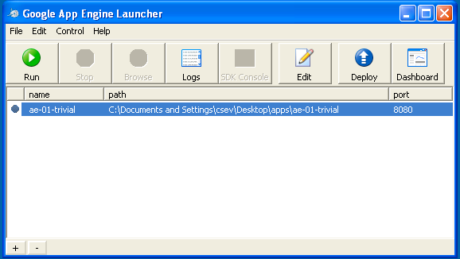

Once you have selected your application and press **Run**. After a few moments your application will start and the launcher will show a little green icon next to your application. Then press **Browse** to open a browser pointing at your application which is running at **http://localhost:8080/**

Paste **http://localhost:8080** into your browser and you should see your application asfollows:

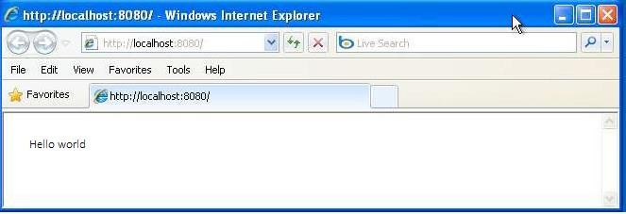

Just forfun, edit the **index.py** tochangethe name “Chuck” toyourownnameand press Refresh in the browser to verify your updates.

## Watching the Log

You can watchtheinternallogoftheactionsthatthewebserverisperformingwhen youareinteracting with your application in the browser. Select your application in the Launcher and press the **Logs** button to bring up a log window:

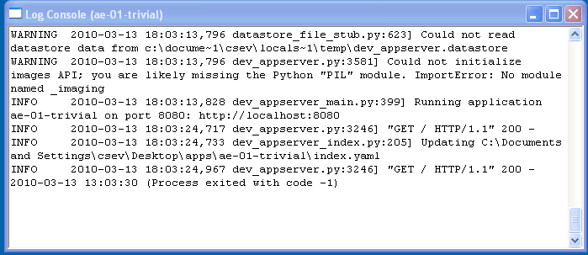

Each time you press **Refresh** in your browser – you can see it retrieving the output with a **GET**

request.

## Dealing With Errors

With two files to edit, there are two general categories of errors that you may encounter. If you make a mistake on the **app.yaml** file, the App Engine will not start and your launcher will show a yellow icon near your application:

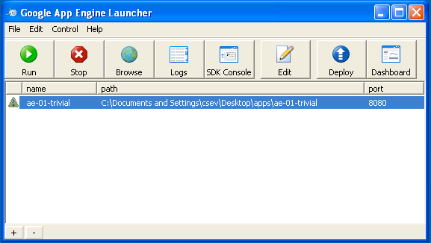

To get more detail on what is going wrong, take a look at the log for the application: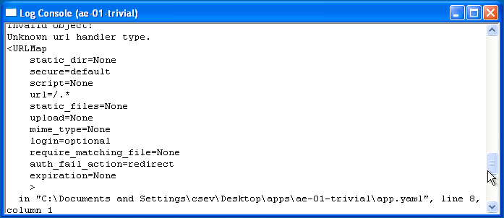

In this instance – the mistake is mis-­‐indenting the last line in the **app.yaml** (line 8).

Ifyou makeasyntaxerrorinthe **index.py** file, a Pythontraceback errorwillappear in your browser.

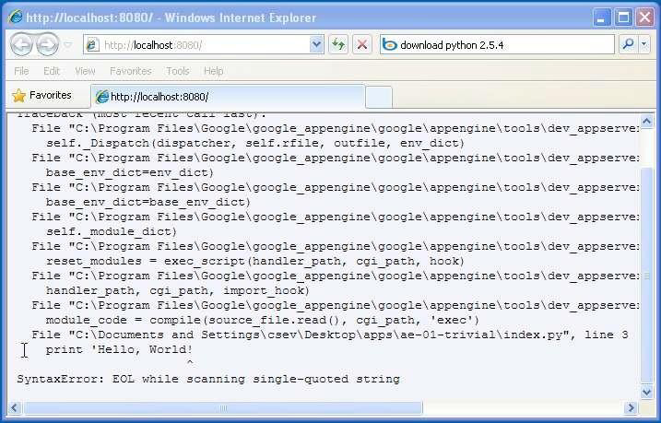

Theerroryouneedtoseeislikelytobethelastfewlinesoftheoutput– inthiscase I made a Python syntax error on line one of our one-•‐line application.

Reference: <http://en.wikipedia.org/wiki/Stack_trace>

Whenyoumakeamistake inthe **app.yaml** file– youmustthefixthemistakeand attempt to start the application again.

Ifyou makeamistakeinafilelikei**ndex.py**, you can simplyfixthefileandpress refresh in your browser – there is no need to restart the server.

## Shutting Down the Server

To shut down the server, use the Launcher, select your application and press the **Stop** button.

# RESULT:

Thus the Google App Engine was installed and *hello world* app and other simple web applications was created using python/java.

| **Ex. No:4**  **Date :** | **Use GAE launcher to launch the web applications.** |
| --- | --- |

# AIM:

To use GAE launcher to launch the web applications.

# PROCEDURE:

**Step 1. Download the basic housekeeping stuff**

No matter what platform you build products on, there is always some housekeeping stuff you need to put in place before you can hit the ground running. And deploying apps within the Google App Engine is no exception.

# Download [Python 2.7](https://www.python.org/download/releases/2.7/)

As of when this article was written, the Google App Engine [standard environment supports Python](https://cloud.google.com/appengine/docs/standard/python/) [only upto version 2.7.](https://cloud.google.com/appengine/docs/standard/python/) However, it is only a matter of time before support for Python 3.x is added. You can check the App Engine docs for the latest info.

# Download [Google Cloud SDK](https://cloud.google.com/appengine/docs/standard/python/download)

This will allow you to fork apps onto your local machine, make changes (edit and develop the app), and deploy your app back to the cloud.

# Set the Python path in the Google App Engine launcher

After downloading the SDK, launch the App Engine launcher, go to Edit -> Preferences and make sure you set the path for where you installed Python in step 1 above.

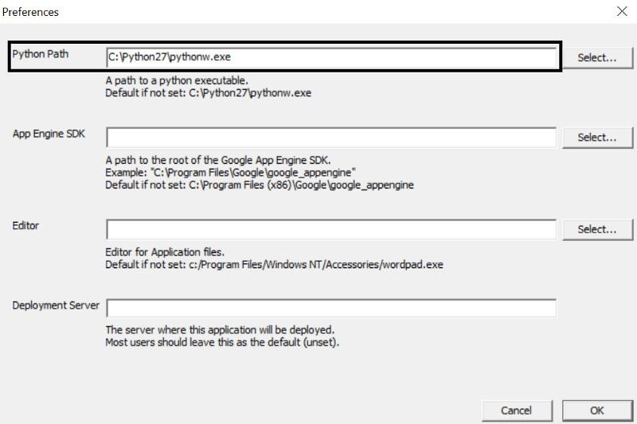

Set the Python path in Google App Engine launcher

That’s all you need. Your local machine should now be ready to build webapps.

# Step 2. App Engine sign-up

This is often the most confusing part of the entire setup. Things you should know when you sign-up:

1. Currently, App Engine offers a free trial for one year.
2. The trial includes $300 of credit that can be used during the one year trial period.
3. You will need to add a credit card to sign-up (for verification purposes).
4. You will not be charged during the sign-up process.
5. You will not be charged during the trial period as long as you do not cross the credit limit offered.

# Here are the steps you need to follow to sign-up:

1. Go to the [Google Cloud](https://cloud.google.com/) landing page
2. Follow the sign-up process and go to your App Engine dashboard Most of the hard work is complete after a successful sign-up.

# Step 3. Create a new project

The next step is to create a new Python project that you can work on. Follow the screenshots below to create a new project.

Launch the new project wizard.



Image courtesy. [h](https://console.cloud.google.com/home)ttps://console.cloud.google.com/home

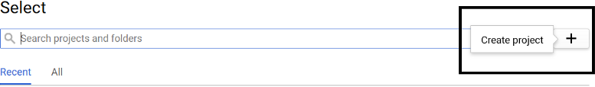

Image courtesy <https://console.cloud.google.com/home>

Give your app a name and make a note of your project ID.

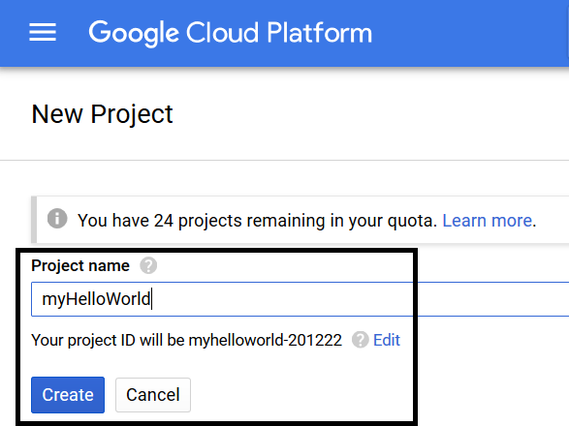

Image courtesy. <https://console.cloud.google.com/home>

Hit the create button and Google should take a few minutes to set up all that is necessary for your newly created app.

# Step 4. Fork the app to develop it locally

The next step in the process is to fork the app on your local machine. This will allow you to make changes to the app locally and deploy it whenever you wish to.

Go to Google App Engine launcher and create a new application.

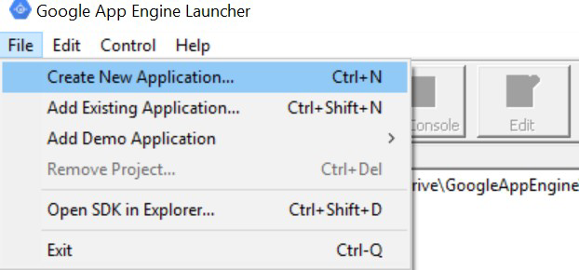

Enter the project ID of your newly created app. Also, provide the folder (local destination) where you wish to store the app locally. Make sure you select the Python 2.7 as your runtime engine.

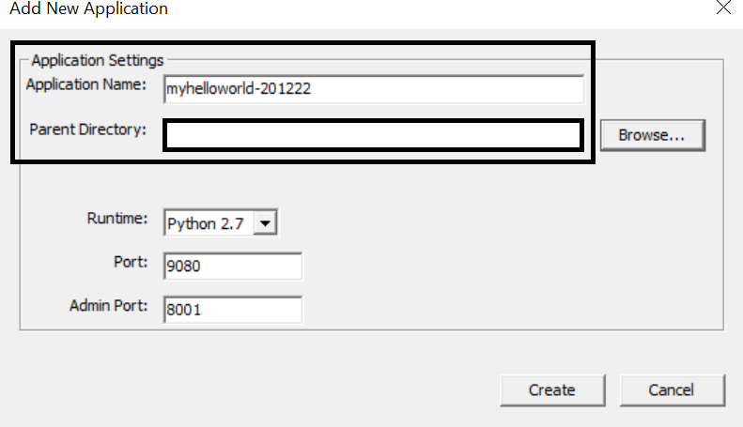

Hit the create button, and you should see your app listed on the window that follows. You should also check that you now see some files in your local storage (the directory you chose in the screenshot above) after this step.

# Step 5. Run the app locally

Before you go ahead and make some changes to the app, it is important to check whether or not you have executed all the above steps correctly. This can be done by simply running the app locally.

Select the app and hit the run button on the window.

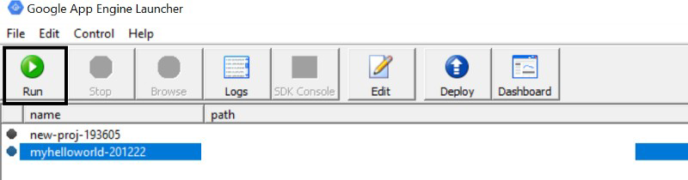

Wait for a few seconds until you can hit the **Browse** button. Once the **Browse** button becomes clickable, click it. This should take you to the browser, and you should see the hello world text appear in your browser window. Alternatively, you can manually go to the browser and use the port specified to access the app.

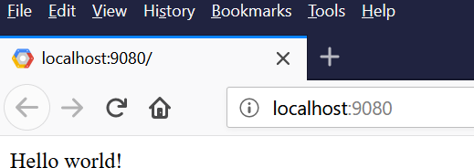

As long as you see the above screen, you are all set.

# Step 6. Understand the app structure

It is finally time to look at the lines of code which are running this webapp. Open your app folder in the text editor of your choice. I recommend [Sublime text](https://www.sublimetext.com/) or [VS Code](https://code.visualstudio.com/). However, feel free to choose the one you prefer.

Here is a description of the various files.

# app.yaml

This file is a basic markup file that stores information (some metadata) about the app. It is important to note the following crucial parts of the file.

# application

This is the project ID which you should never change. This is the unique identifier for the app

1. **url -> scr**ipt

This is the homepage for the app. In other words, this file will be rendered in your browser when you launch the app

# libraries

This is where you can include external libraries to use within the webapp

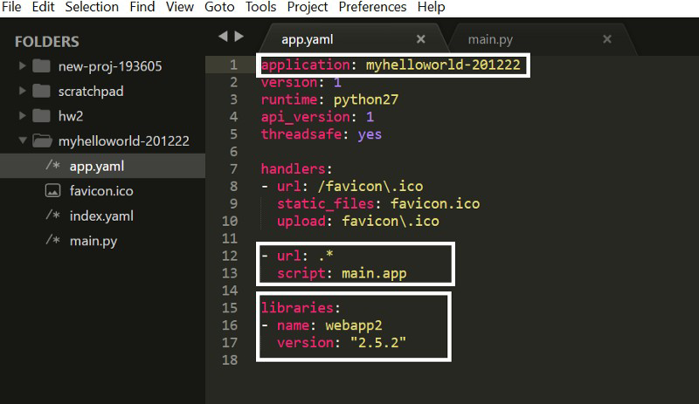

app.yaml file in the webapp folder

# main.py

This is the homepage of the app (as discussed above). Note that the hello world text in the browser window (step 5) is due to the code you see highlighted below.

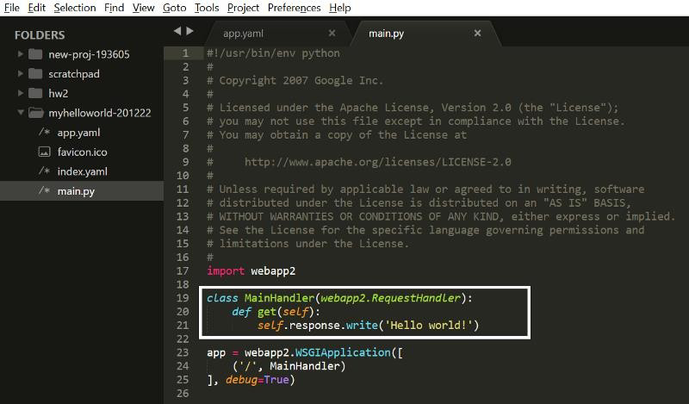

main.py file in the webapp folder

# Step 7. Make your changes and deploy the new app

No hello world app is ever complete without the developer changing the hello world text to something else just to make sure that everything happening behind the scenes is working as it should.

Go ahead and change the text in the above screenshot to something else.

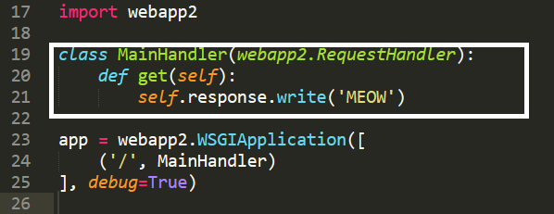

main.py file in the webapp folder

Save the changes, go to the browser and refresh the page. You should see the page with the text “MEOW” displayed.

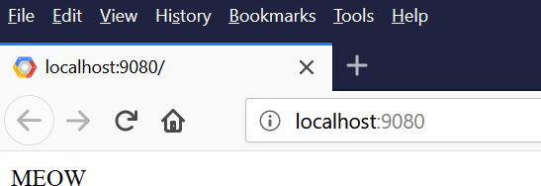

Finally, it is time to deploy your changes to the cloud to make them globally accessible via a URL. Go to the App Engine launcher, select the app, and hit the **Deploy** button.

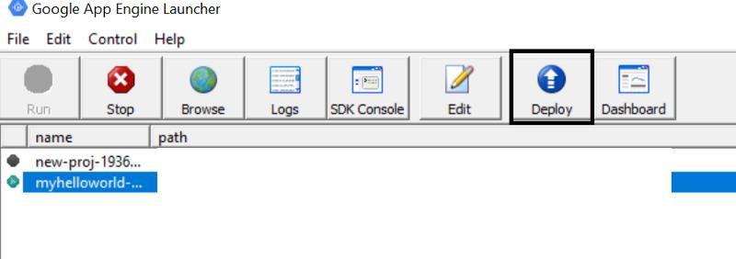

This will ensure your app gets deployed onto Google Cloud. To check whether or not everything worked just fine, go to the URL below:

# https://<yourProjectID>.appspot.com/

You should see the exact same window as above, expect now, it is a URL that is globally accessible.

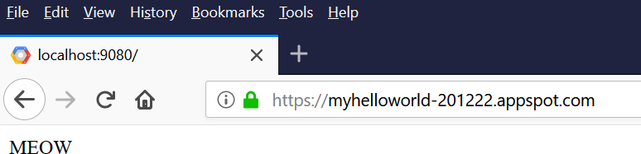

# Step 8. Misc

Congratulations, you’ve finally gotten your first Python webapp deployed on the Google App Engine. Here are some other points which you may find useful.

1. [Jinja 2](http://jinja.pocoo.org/docs/2.10/) is an amazing front end templating library for Python that can do some cool stuff, such as passing objects form Python to HTML, using for loops, if conditions, and so on directly out of the box
2. [Here’s](https://classroom.udacity.com/courses/cs253) a very useful Udacity course on web development that I have personally found quite resourceful
3. Viewing the logs while running your webapp can be handy to debug and also discover some bugs on the fly

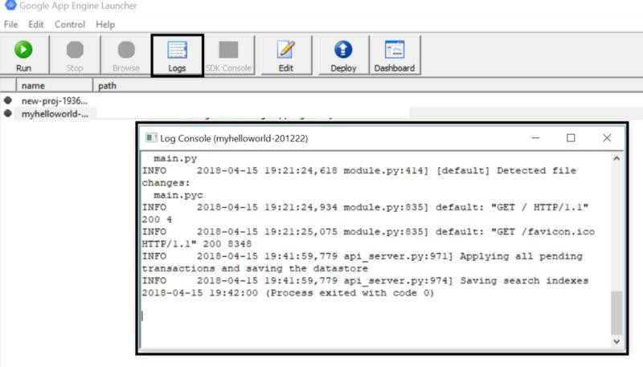

Log console of the webapp

# RESULT:

Thus the GAE launcher is used successfully to launch the web applications.

| **Ex. No:5**  **Date:** | **Simulate a cloud scenario using CloudSim and run a scheduling algorithm that is not present in CloudSim.** |
| --- | --- |

# AIM:

To Simulate a cloud scenario using CloudSim and run a scheduling algorithm that is not

present in CloudSim.

# PROCEDURE:

**How to use CloudSim in Eclipse**

CloudSim is written in Java. The knowledge you need to use CloudSim is basic Java programming and some basics about cloud computing. Knowledge of programming IDEs such as Eclipse or NetBeans is also helpful. It is a library and, hence, CloudSim does not have to be installed. Normally, you can unpack the downloaded package in any directory, add it to the Java classpath and it is ready to be used. Please verify whether Java is available on your system.

# To use CloudSim in Eclipse:

1. Download CloudSim installable files from

*https://code.google.com/p/cloudsim/downloads/list and unzip*

1. Open Eclipse
2. Create a new Java Project: File -> New
3. Import an unpacked CloudSim project into the new Java Project
4. The first step is to initialise the CloudSim package by initialising the CloudSim library, as follows:

CloudSim.init(num_user, calendar, trace_flag)

1. Data centres are the resource providers in CloudSim; hence, creation of data centres is a second step. To create Datacenter, you need the DatacenterCharacteristics object that stores the properties of a data centre such as architecture, OS, list of machines, allocation policy that covers the time or spaceshared, the time zone and its price:

Datacenter datacenter9883 = new Datacenter(name, characteristics, new VmAllocationPolicySimple(hostList), s)

1. The third step is to create a broker:

DatacenterBroker broker = createBroker();

1. The fourth step is to create one virtual machine unique ID of the VM, userId ID of the VM’s owner, mips, number Of Pes amount of CPUs, amount of RAM, amount of bandwidth, amount of storage, virtual machine monitor, and cloudletScheduler policy for cloudlets:

Vm vm = new Vm(vmid, brokerId, mips, pesNumber, ram, bw, size, vmm, new CloudletSchedulerTimeShared())

1. Submit the VM list to the broker:

broker.submitVmList(vmlist)

1. Create a cloudlet with length, file size, output size, and utilisation model:

Cloudlet cloudlet = new Cloudlet(id, length, pesNumber, fileSize, outputSize, utilizationModel, utilizationMode

1. Submit the cloudlet list to the broker:

broker.submitCloudletList(cloudletList)

1. Start the simulation:

CloudSim.startSimulation()

# Sample Output from the Existing Example:

Starting CloudSimExample1... Initialising...

Starting CloudSim version 3.0 Datacenter_0 is starting...

>>>>>>>>>>>>>>>>>>>>>>>>>>>>>>>>null

Broker is starting… Entities started.

: Broker: Cloud Resource List received with 1 resource(s) 0.0: Broker: Trying to Create VM #0 in Datacenter_0

: Broker: VM #0 has been created in Datacenter #2, Host #0 0.1: Broker: Sending cloudlet 0 to VM #0

400.1: Broker: Cloudlet 0 received

: Broker: All Cloudlets executed. Finishing...

* 1. : Broker: Destroying VM #0 Broker is shutting down...

Simulation: No more future events

CloudInformationService: Notify all CloudSim entities for shutting down. Datacenter_0 is shutting down...

Broker is shutting down... Simulation completed.

Simulation completed.

========== OUTPUT ==========

Cloudlet ID STATUS Data center ID VM ID Time Start Time Finish Time 0 SUCCESS 2 0 400 0.1 400.1

*****Datacenter: Datacenter_0***** User id Debt 3 35.6

CloudSimExample1 finished!

# RESULT:

Thus a cloud scenario using CloudSim was simulated and a scheduling algorithm that is not present in CloudSim was executed successfully.

| **Ex. No:6**  **Date:** | **Find a procedure to transfer the files from one virtual machine to another virtual machine.** |
| --- | --- |

# AIM:

machine.

To find a procedure to transfer the files from one virtual machine to another virtual

# PROCEDURE:

* + 1. You can copy few (or more) lines with ***copy & paste*** mechanism.

For this you need [to share clipboard between host OS and guest OS](https://superuser.com/questions/42134/virtualbox-shared-clipboard), installing **Guest Addition** on both the virtual machines (probably setting *bidirectional* and restarting them). You *copy* from *guest OS* in the clipboard that is shared with the *host OS*.

Then you *paste* from the *host OS* to the second *guest OS*.

* + 1. You can enable **drag and drop** too with the same method (Click on the machine, settings, general, advanced, drag and drop: set to *bidirectional* )
    2. You can have **common *Shared Folders*** on both virtual machines and use one of the directory shared as buffer to copy.

Installing **Guest Additions** you have the possibility to set [Shared Folders too](https://www.virtualbox.org/manual/ch04.html#sharedfolders). As you put a file in a shared folder from *host OS* or from *guest OS*, is immediately visible to the other. (Keep in mind that can arise some problems for date/time of the files when there are different clock settings on the different virtual machines).

*If you use the same folder shared on more machines you can exchange files directly copying them in this folder.*

* + 1. You can use **usual method to copy files between 2 different computer** with client-server application. (e.g. scp with sshd active for linux, winscp... [you can get some info about SSH](http://en.wikipedia.org/wiki/Comparison_of_SSH_servers) [servers e.g. here](http://en.wikipedia.org/wiki/Comparison_of_SSH_servers))

You need an active server (sshd) on the receiving machine and a client on the sending machine. Of course you need to have the authorization setted (via password or, better, via an [automatic](https://help.github.com/articles/generating-ssh-keys) [authentication method](https://help.github.com/articles/generating-ssh-keys)).

**Note:** many Linux/Ubuntu distribution install sshd by default: you can see if it is running with pgrep sshd from a shell. You can install with sudo apt-get install openssh-server.

* + 1. You can **mount part of the file system** of a virtual machine via [NFS](http://en.wikipedia.org/wiki/Network_File_System) or [SSHFS](http://en.wikipedia.org/wiki/SSHFS) on the other, or you can **share file and directory** with Samba.

You may find interesting the article [Sharing files between guest and host without](https://www.virtualbox.org/wiki/Sharing_files_on_OSE) [VirtualBox](https://www.virtualbox.org/wiki/Sharing_files_on_OSE) [shared folders](https://www.virtualbox.org/wiki/Sharing_files_on_OSE) with detailed step by step instructions.

You should remember that you are deling with a little network of machines with different operative systems, and in particular:

* Each virtual machine has its own operative system running on and acts as a physical machine.
* Each virtual machine is an instance of a program *owned* by an *user* in the hosting operative system and should undergo the restrictions of the *user* in the *hosting OS*.

E.g Let we say that Hastur and Meow are users of the hosting machine, but they did not allow each other to see their directories (no read/write/execute authorization). When each of them run a virtual machine, for the hosting OS those virtual machine are two normal programs owned by Hastur and Meow and cannot see the private directory of the other user. This is a restriction due to the *hosting OS*. It's easy to overcame it: it's enough to give authorization to read/write/execute to a directory or to chose a different directory in which both users can read/write/execute.

* Windows likes mouse and Linux fingers.

I mean I suggest you to enable *Drag & drop* to be cosy with the Windows machines and the

*Shared folders* or to be cosy with Linux.

When you will need to be fast with Linux **you will feel the need** of ssh-keygen and

to [Generate once SSH Keys](https://help.github.com/articles/generating-ssh-keys) to copy files on/from a remote machine without writing password anymore. In this way it functions bash auto-completion remotely too!

# RESULT:

Thus a procedure to transfer the files from one virtual machine to another virtual machine was found and the files are transferred successfully.

| **Ex. No:7**  **Date:** | **Find a procedure to launch virtual machine using trystack (Online Openstack Demo Version)** |
| --- | --- |

**AIM**:

To find a procedure to launch virtual machine using trystack (Online Openstack

Demo Version)

# PROCEDURE:

[**OpenStack**](http://www.openstack.org/) is an open-source software cloud computing platform. OpenStack is primarily used for deploying an infrastructure as a service (IaaS) solution like Amazon Web Service (AWS). In other words, you can *make your own AWS* by using OpenStack. If you want to try out OpenStack, [**TryStack**](http://trystack.org/) is the easiest and free way to do it.

In order to try OpenStack in TryStack, you must register yourself by joining [TryStack Facebook](https://www.facebook.com/groups/269238013145112) [Group.](https://www.facebook.com/groups/269238013145112) The acceptance of group needs a couple days because it’s approved manually. After you have been accepted in the TryStack Group, you can log in TryStack.

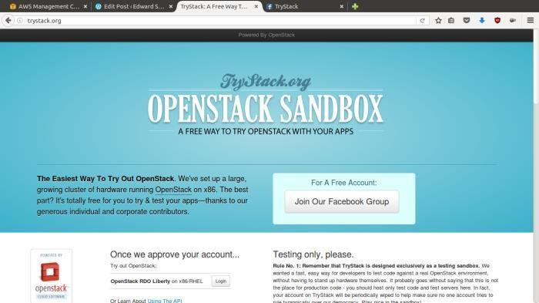

TryStack.org Homepage

I assume that you already join to the Facebook Group and login to the dashboard. After you log in to the TryStack, you will see the Compute Dashboard like:

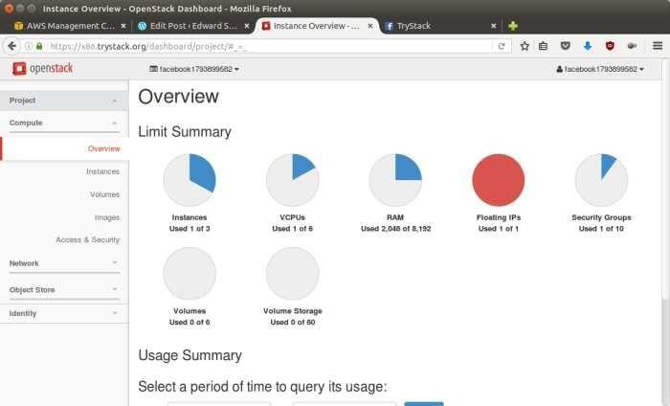

OpenStack Compute Dashboard

# Overview: What we will do?

In this post, I will show you how to run an OpenStack instance. The instance will be accessible through the internet (have a public IP address). The final topology will like: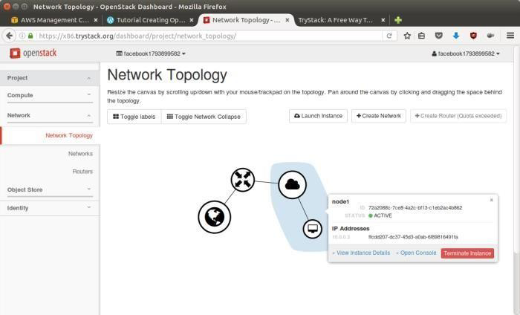

Network topology

As you see from the image above, the instance will be connected to a local network and the local network will be connected to internet.

# Step 1: Create Network

Network? Yes, the network in here is our own local network. So, your instances will be not mixed up with the others. You can imagine this as your own LAN (Local Area Network) in the cloud.

1. Go to **Network > Networks** and then click **Create Network**.
2. In **Network** tab, fill **Network Name** for example internal and then click **Next**.
3. In **Subnet** tab,
   1. Fill **Network Address** with appropriate CIDR, for example 192.168.1.0/24. Use [private](https://en.wikipedia.org/wiki/Private_network) [network CIDR block](https://en.wikipedia.org/wiki/Private_network) as the best practice.
   2. Select **IP Version** with appropriate IP version, in this case IPv4.
   3. Click **Next**.
   4. In **Subnet Details** tab, fill **DNS Name Servers** with 8.8.8.8 (Google DNS) and then click **Create**.

# Step 2: Create Instance

Now, we will create an instance. The instance is a virtual machine in the cloud, like AWS EC2. You need the instance to connect to the network that we just created in the previous step.

* + 1. Go to **Compute > Instances** and then click **Launch Instance**.
    2. In **Details** tab,
       1. Fill **Instance Name**, for example Ubuntu 1.
       2. Select **Flavor**, for example m1.medium.
       3. Fill **Instance Count** with **1**.
       4. Select **Instance Boot Source** with **Boot from Image**.
       5. Select **Image Name** with **Ubuntu 14.04 amd64 (243.7 MB)** if you want install Ubuntu

14.04 in your virtual machine.

* + 1. In **Access & Security** tab,
       1. Click [**+**] button of **Key Pair** to import key pair. This key pair is a public and private key that we will use to connect to the instance from our machine.
       2. In **Import Key Pair** dialog,
          1. Fill **Key Pair Name** with your machine name (for example Edward-Key).
          2. Fill **Public Key** with your **SSH public key** (usually is in ~/.ssh/id_rsa.pub). See description in Import Key Pair dialog box for more information. If you are using Windows, you can use **Puttygen** to generate key pair.
          3. Click **Import key pair**.
       3. In **Security Groups**, mark/check **default**.
       4. In **Networking** tab,
          1. In **Selected Networks**, select network that have been created in Step 1, for example internal.
       5. Click **Launch**.
       6. If you want to create multiple instances, you can repeat step 1-5. I created one more instance with instance name Ubuntu 2.

# Step 3: Create Router

I guess you already know what router is. In the step 1, we created our network, but it is isolated. It doesn’t connect to the internet. To make our network has an internet connection, we need a router that running as the gateway to the internet.

1. Go to **Network > Routers** and then click **Create Router**.
2. Fill **Router Name** for example router1 and then click **Create router**.
3. Click on your **router name link**, for example router1, **Router Details** page.
4. Click **Set Gateway** button in upper right:
   1. Select **External networks** with **external**.
   2. Then **OK**.
5. Click **Add Interface** button.
   1. Select **Subnet** with the network that you have been created in Step 1.
   2. Click **Add interface**.
6. Go to **Network > Network Topology**. You will see the network topology. In the example, there are two network, i.e. external and internal, those are bridged by a router. There are instances those are joined to internal network.

# Step 4: Configure Floating IP Address

*Floating IP address* is public IP address. It makes your instance is accessible from the internet. When you launch your instance, the instance will have a private network IP, but no public IP. In OpenStack, the public IPs is collected in a pool and managed by admin (in our case is TryStack). You need to request a public (floating) IP address to be assigned to your instance.

* 1. Go to **Compute > Instance**.
  2. In one of your instances, click **More > Associate Floating IP**.
  3. In **IP Address**, click Plus [**+**].
  4. Select **Pool** to **external** and then click **Allocate IP**.
  5. Click **Associate**.
  6. Now you will get a public IP, e.g. 8.21.28.120, for your instance.

# Step 5: Configure Access & Security

OpenStack has a feature like a firewall. It can whitelist/blacklist your in/out connection. It is called

*Security Group*.

* + 1. Go to **Compute > Access & Security** and then open **Security Groups** tab.
    2. In **default** row, click **Manage Rules**.
    3. Click **Add Rule**, choose **ALL ICMP** rule to enable ping into your instance, and then click

**Add**.

* + 1. Click **Add Rule**, choose **HTTP** rule to open HTTP port (port 80), and then click **Add**.
    2. Click **Add Rule**, choose **SSH** rule to open SSH port (port 22), and then click **Add**.
    3. You can open other ports by creating new rules.

# Step 6: SSH to Your Instance

Now, you can SSH your instances to the floating IP address that you got in the step 4. If you are using Ubuntu image, the SSH user will be ubuntu.

# RESULT:

Thus the procedure to launch virtual machine using trystack (Online Openstack Demo Version) was executed successfully.

| **Ex. No:8**  **Date:** | **Install Hadoop single node cluster and run simple applications like wordcount.** |
| --- | --- |

# AIM:

To install Hadoop single node cluster and run simple applications like wordcount.

# PROCEDURE:

**Install Hadoop**

**Step 1:** Click here to download the Java 8 Package. Save this file in your home directory.

**Step 2:** Extract the Java Tar File.

***Command*:** tar -xvf jdk-8u101-linux-i586.tar.gz

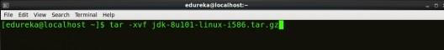

*Fig: Hadoop Installation – Extracting Java Files*

# Step 3: Download the Hadoop 2.7.3 Package.

***Command*:** wget https://archive.apache.org/dist/hadoop/core/hadoop-2.7.3/hadoop- 2.7.3.tar.gz

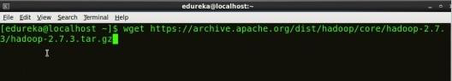

*Fig: Hadoop Installation – Downloading Hadoop*

**Step 4:** Extract the Hadoop tar File.

***Command***: tar -xvf hadoop-2.7.3.tar.gz

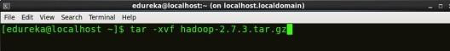

*Fig: Hadoop Installation – Extracting Hadoop Files* **Step 5:**

Add the Hadoop and Java paths in the bash file (.bashrc). Open**. bashrc** file. Now, add Hadoop and Java Path as shown below.

***Command*:** vi .bashrc

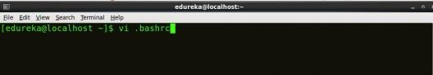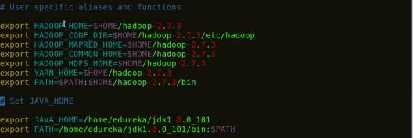

*Fig: Hadoop Installation – Setting Environment Variable*

Then, save the bash file and close it.

For applying all these changes to the current Terminal, execute the source command.

***Command*:** source .bashrc

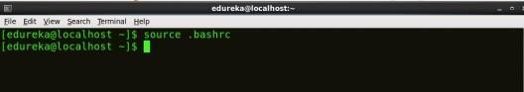

*Fig: Hadoop Installation – Refreshing environment variables*

To make sure that Java and Hadoop have been properly installed on your system and can be accessed through the Terminal, execute the java -version and hadoop version commands.

***Command*:** java -version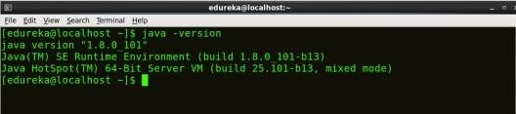

*Fig: Hadoop Installation – Checking Java Version*

***Command*:** hadoop version

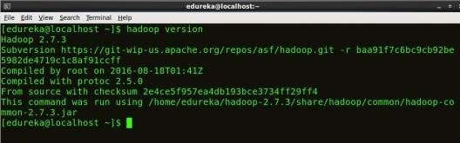

*Fig: Hadoop Installation – Checking Hadoop Version*

**Step 6:** Edit the **Hadoop Configuration files**.

***Command:*** cd hadoop-2.7.3/etc/hadoop/

## Command: ls

All the Hadoop configuration files are located in **hadoop-2.7.3/etc/hadoop** directory as you can see in the snapshot below: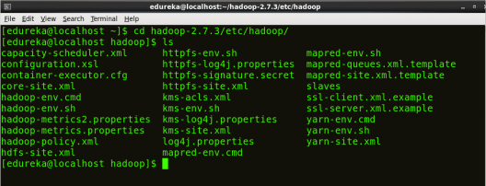

*Fig: Hadoop Installation – Hadoop Configuration Files*

**Step 7:** Open *core-site.xml* and edit the property mentioned below inside configuration tag:

*core-site.xml* informs Hadoop daemon where NameNode runs in the cluster. It contains configuration settings of Hadoop core such as I/O settings that are common to HDFS & MapReduce.

***Command*:** vi core-site.xml

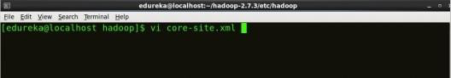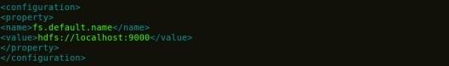

1

2

3

4

5

6

7

8

<?xml version="1.0" encoding="UTF-8"?>

<?xml-stylesheet type="text/xsl" href="configuration.xsl"?>

<configuration>

<property>

<name>fs.default.name</name>

<value>hdfs://localhost:9000</value>

</property>

</configuration>

*Fig: Hadoop Installation – Configuring core-site.xml*

**Step 8:** Edit *hdfs-site.xml* and edit the property mentioned below inside configuration tag:

*hdfs-site.xml* contains configuration settings of HDFS daemons (i.e. NameNode, DataNode, Secondary NameNode). It also includes the replication factor and block size of HDFS.

***Command*:** vi hdfs-site.xml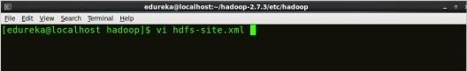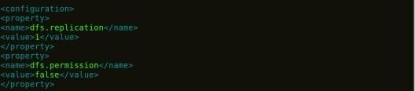

*Fig: Hadoop Installation – Configuring hdfs-site.xml*

1

2

3

4

5

6

7

8

9

10

11

12

<?xml version="1.0" encoding="UTF-8"?>

<?xml-stylesheet type="text/xsl" href="configuration.xsl"?>

<configuration>

<property>

<name>dfs.replication</name>

<value>1</value>

</property>

<property>

<name>dfs.permission</name>

<value>false</value>

</property>

</configuration>

**Step 9:** Edit the *mapred-site.xml* file and edit the property mentioned below

# inside configuration tag:

*mapred-site.xml* contains configuration settings of MapReduce application like number of JVM that can run i parallel, the size of the mapper and the reducer process, CPU cores available for a process, etc.

In some cases, mapred-site.xml file is not available. So, we have to create the mapred- site.xml file using mapred-site.xml template.

***Command*:** cp mapred-site.xml.template mapred-site.xml

***Command*:** vi mapred-site.xml.

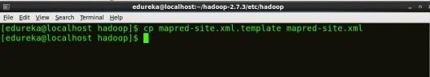

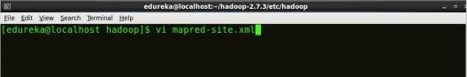



*Fig: Hadoop Installation – Configuring mapred-site.xml*

1

2

3

4

5

6

7

8

<?xml version="1.0" encoding="UTF-8"?>

<?xml-stylesheet type="text/xsl" href="configuration.xsl"?>

<configuration>

<property>

<name>mapreduce.framework.name</name>

<value>yarn</value>

</property>

</configuration>

**Step 10:** Edit *yarn-site.xml* and edit the property mentioned below inside configuration tag:

*yarn-site.xml* contains configuration settings of ResourceManager and NodeManager like application memory management size, the operation needed on program & algorithm, etc.

***Command*:** vi yarn-site.xml

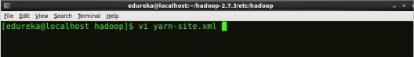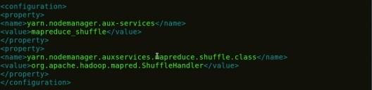

*Fig: Hadoop Installation – Configuring yarn-site.xml*

1

2

3

4

5

6

7

8

9

1

0

1

1

<?xml version="1.0">

<configuration>

<property>

<name>yarn.nodemanager.aux-services</name>

<value>mapreduce_shuffle</value>

</property>

<property>

<name>yarn.nodemanager.auxservices.mapreduce.shuffle.class</ name>

<value>org.apache.hadoop.mapred.ShuffleHandler</value>

</property>

</configuration>

**Step 11:** Edit *hadoop-env.sh* and add the Java Path as mentioned below:

*hadoop-env.sh* contains the environment variables that are used in the script to run Hadoop like Java home path, etc.

***Command*:** vi hadoop–env.sh

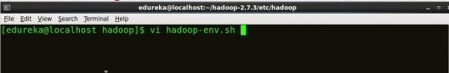

*Fig: Hadoop Installation – Configuring hadoop-env.sh*

**Step 12:** Go to Hadoop home directory and format the NameNode.

***Command*:** cd

***Command*:** cd hadoop-2.7.3

***Command*:** bin/hadoop namenode -format

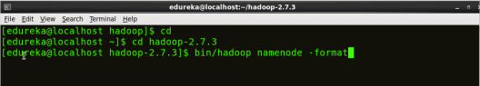

*Fig: Hadoop Installation – Formatting NameNode*

This formats the HDFS via NameNode. This command is only executed for the first time. Formatting the file system means initializing the directory specified by the dfs.name.dir variable.

Never format, up and running Hadoop filesystem. You will lose all your data stored in the HDFS.

**Step 13:** Once the NameNode is formatted, go to hadoop-2.7.3/sbin directory and start all the daemons.

***Command:*** cd hadoop-2.7.3/sbin

Either you can start all daemons with a single command or do it individually.

***Command:*** *./*start-all.sh

The above command is a combination of ***start-dfs.sh, start-yarn.sh*** & ***mr-jobhistory- daemon.sh***

Or you can run all the services individually as below:

# Start NameNode:

The NameNode is the centerpiece of an HDFS file system. It keeps the directory tree of all files stored in the HDFS and tracks all the file stored across the cluster.

***Command:*** ./hadoop-daemon.sh start namenode

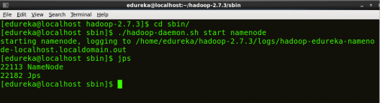

*Fig: Hadoop Installation – Starting NameNode*

# Start DataNode:

On startup, a DataNode connects to the Namenode and it responds to the requests from the Namenode for different operations.

***Command:*** ./hadoop-daemon.sh start datanode

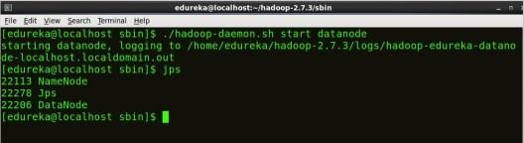

*Fig: Hadoop Installation – Starting DataNode*

# Start ResourceManager:

ResourceManager is the master that arbitrates all the available cluster resources and thus helps in managing the distributed applications running on the YARN system. Its work is to manage each NodeManagers and the each application’s ApplicationMaster.

***Command:*** ./yarn-daemon.sh start resourcemanager

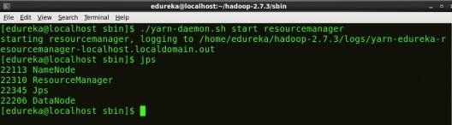

*Fig: Hadoop Installation – Starting ResourceManager*

# Start NodeManager:

The NodeManager in each machine framework is the agent which is responsible for managing containers, monitoring their resource usage and reporting the same to the ResourceManager.

***Command:*** ./yarn-daemon.sh start nodemanager

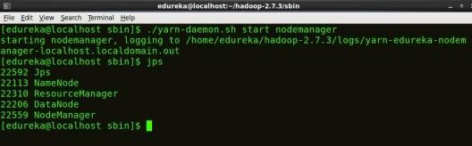

*Fig: Hadoop Installation – Starting NodeManager*

# Start JobHistoryServer:

JobHistoryServer is responsible for servicing all job history related requests from client.

[

***Command*:** ./mr-jobhistory-daemon.sh start historyserver

**Step 14:** To check that all the Hadoop services are up and running, run the below command.

***Command:*** jpsn

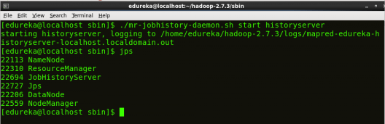

*Fig: Hadoop Installation – Checking Daemons*

**Step 15:** Now open the Mozilla browser and goto **localhost**:**50070/dfshealth.html** to check the NameNode interface.

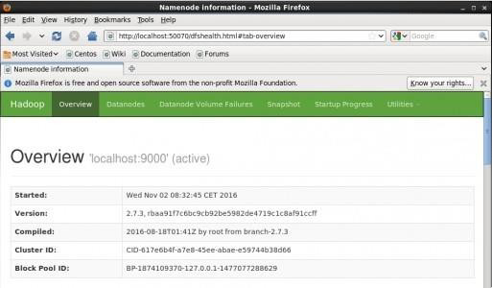

*Fig: Hadoop Installation – Starting WebUI*

Congratulations, you have successfully installed a single node Hadoop cluster

**PROCEDURE FOR WORD COUNT:**

**# su – hadoop**

# $ vim WordCount.java

**/home/hduser/WordCount.java:**

import java.io.IOException; import java.util.StringTokenizer;

import org.apache.hadoop.conf.Configuration; import org.apache.hadoop.fs.Path;

import org.apache.hadoop.io.IntWritable; import org.apache.hadoop.io.Text;

import org.apache.hadoop.mapreduce.Job; import org.apache.hadoop.mapreduce.Mapper; import org.apache.hadoop.mapreduce.Reducer;

import org.apache.hadoop.mapreduce.lib.input.FileInputFormat; import org.apache.hadoop.mapreduce.lib.output.FileOutputFormat; public class WordCount {

public static class TokenizerMapper

extends Mapper<Object, Text, Text, IntWritable>{ private final static IntWritable one = new IntWritable(1); private Text word = new Text();

public void map(Object key, Text value, Context context) throws IOException, InterruptedException {

StringTokenizer itr = new StringTokenizer(value.toString());

while (itr.hasMoreTokens()) { word.set(itr.nextToken()); context.write(word, one); } }

}

public static class IntSumReducer

extends Reducer<Text,IntWritable,Text,IntWritable> { private IntWritable result = new IntWritable();

public void reduce(Text key, Iterable<IntWritable> values,Context context) throws IOException, InterruptedException {

int sum = 0;

for (IntWritable val : values)

{ sum += val.get(); } result.set(sum); context.write(key, result); } }

public static void main(String[] args) throws Exception { Configuration conf = new Configuration();

Job job = Job.getInstance(conf, "word count"); job.setJarByClass(WordCount.class); job.setMapperClass(TokenizerMapper.class); job.setCombinerClass(IntSumReducer.class); job.setReducerClass(IntSumReducer.class); job.setOutputKeyClass(Text.class); job.setOutputValueClass(IntWritable.class); FileInputFormat.addInputPath(job, new Path(args[0]));

FileOutputFormat.setOutputPath(job, new Path(args[1])); System.exit(job.waitForCompletion(true) ? 0 : 1); }

}

# Start Hadoop Cluster

$ cd /home/hadoop/hadoop/sbin/

$ start-dfs.sh

$ start-yarn.sh

$ hadoop fs –mkdir /cloud

$ hadoop fs -ls

# COPYING A FILE INTO HDFS INPUT DIRECTORY

**ROOT USER (open in new terminal)**

# su – hadoop

$ vim 5.txt

any messagae type here

:wq

# Hadoop user(old terminal)

$ hadoop fs -put /home/hadoop/5.txt /cloud

$ hadoop fs -ls /cloud

$ hadoop fs -cat /cloud/5.txt

# Download the jar file

$cd /home/hadoop

$pwd

/home/hadoop

$wget ftp://115.248.6.21/hadoop-core-1.2.1.jar

$ ls (Check the file)

# hadoop-core-1.2.1.jar

**Create a Directory to collect class files**

$ mkdir /home/hadoop/wc

# Compiling the java file - WordCount.java

$ javac -classpath /home/hadoop/hadoop-core-1.2.1.jar -d /home/hadoop/wc

/home/hadoop/WordCount.java

$ ls /home/hadoop/wc

WordCount.class WordCount$IntSumReducer.class WordCount$TokenizerMapper.class

# Creating jar file for WordCount.java

$ jar -cvf /home/hadoop/wc.jar -C /home/hadoop/wc/ **.**

added manifest

adding: WordCount.class(in = 1497) (out= 808)(deflated 46%)

adding: WordCount$TokenizerMapper.class(in = 1732) (out= 750)(deflated 56%) adding: WordCount$IntSumReducer.class(in = 1731) (out= 734)(deflated 57%)

# Executing jar file for WordCount.java

$ **hadoop jar /home/hadoop/wc.jar WordCount /cloud/5.txt /cse/rad**

Map-Reduce Framework

Map input records=9 Map output records=146

Map output bytes=1621

Map output materialized bytes=1465 Input split bytes=98

Combine input records=146 Combine output records=106 Reduce input groups=106 Reduce shuffle bytes=1465 Reduce input records=106 Reduce output records=106 Spilled Records=212 Shuffled Maps =1

Failed Shuffles=0 Merged Map outputs=1 GC time elapsed (ms)=29

CPU time spent (ms)=1130

Physical memory (bytes) snapshot=397852672 Virtual memory (bytes) snapshot=1907441664 Total committed heap usage (bytes)=245235712

Shuffle Errors

BAD_ID=0 CONNECTION=0 IO_ERROR=0 WRONG_LENGTH=0

WRONG_MAP=0 WRONG_REDUCE=0

File Input Format Counters Bytes Read=1042

File Output Format Counters Bytes Written=1035

# $ hadoop fs -ls /cse/rad

16/08/25 15:34:20 WARN util.NativeCodeLoader: Unable to load native-hadoop library for your platform... using builtin-java classes where applicable

Found 2 items

-rw-r--r-- 1 hadoop supergroup 0 2016-08-25 15:33 /cse/rad/_SUCCESS

-rw-r--r-- 1 hadoop supergroup 1035 2016-08-25 15:33 /cse/rad/part-r-00000

# $ hadoop fs -cat /cse/rad/*

16/08/25 15:34:53 WARN util.NativeCodeLoader: Unable to load native-hadoop library for your platform... using builtin-java classes where applicable

(CentOS 1

100% 1

American 1

CentOS 5

Chat, 1

Community 1

**RESULT:**

Thus the Hadoop single node cluster was successfully installed and a simple application like wordcount was executed successfully.